Item Classification Reason
Patients Entity because its an object
Doctors Entity because its an object
Departments Entity because its an object
Services Entity because its an object
Records Entity because its an object
Appointments Entity because its an object
Billing Entity because its an object
patID Attribute identifies patient
DocID Attribute identifies doctor
depname Attribute Describes department
name Attribute name of the person
gender Attribute type of gender
email Attribute Contact information
number Attribute phone numbers
Blood/G Attribute Blood group of patient
BD (DOB) Attribute Used to define age
price Attribute Cost of service
type (service) Attribute Categorizes service
type (appointment) Attribute Type of appointment
date Attribute Appointment date
status Attribute Appointment state
paydetails Attribute Billing information
works (Doctor\Department) Relationship Connects doctor and department
has (patient-appointment/record/billing) Relationship connects between patient-appointment/record/billing

includes (appointment-service) Relationship One appointment has many services
include (billing-service) Relationship Billing depends on services

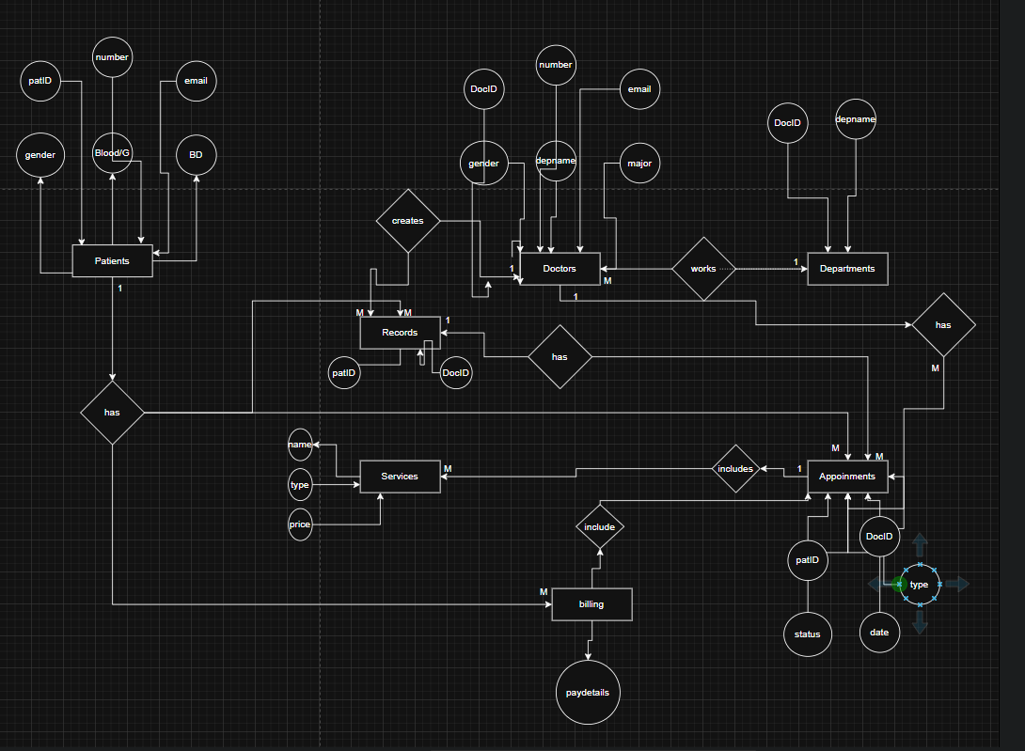

Part 2

